MAMBAU INTERNATIONAL SCHOOL, KARIMUGHAL, KOCHI
PROJECT REPORT TO START THE SCHOOL
1. Scope of School Project
Education sector is one of the growing sector in world wide as quality education is the backbone of Education Industry. As a growing India, education is being focused as a prime moto by the all literate class. Therefore, Private Equity Investors have already sense this opportunity and rising demand trend has already started funding education projects. India’s private banking giant HDFC has confirmed that Private Equity investment is seeing a tremendous surge since year 2005. Private Equity investment is nearly touching the $190 million market in year 2010. Whereas in the year 2005 the level of private equity investment was not more than $20 million.
India has one of the youngest populations in the world. In India the quality of primary and secondary school education is not as per world’s standards. The number of people who are waiting for quality education and availability of top class education has a great imbalance. This is allowing India to become the best target to feed private equity investment in educational sector.
Educational sector is one of those sectors which are not heavily effected in times of financial crisis like year 2008. The cash flow in education is always assured and schools are not dependent on financing their working capital. This makes the education sector as one the most promising sector of 2011 and beyond as well as the assured Private investment sector.
2. Place in a district town
Constituting a school in big cities/ Metros require lots of investment as compared to small city. In Small city we can start a school with world class facility in RS. 6 to 8 crores whereas in big city requires at least Rs 10 to 15 crores. If we compare about the competition there are lots of reputed school in big city. For Example in Delhi we have at least 50+ world class school where as in small cities there are hardly any good one. Due to the lack of quality education students from small city are forced to move for big cities. Hence, we provide world class education with world class facilities it is easier for us to establish as a leading brand in short span of time.
3. Our Vision
- The intellectual, social, emotional, physical, spiritual and aesthetic development of the students is fostered to enhance their quality of life.
- To provide International Standard Quality Co-education facility.
- Residential & day boarding schooling facilities
- Initially for 10 +2 standard class schooling & gradually leads to higher technical/ medical education etc.
- All establishment shall be Govt. approved/ affiliated by the concerned authorities.

4. Our Strength
- A group of educationist support- world wide
- 3rd generation Quality Education
- Electronic Media Education Policy
- Prudent Infrastructure & huge campus
- Maximum well versed feminine teaching Faculty.
- Education –Spiritual to Scientific Education Policy
5. Infrastructure: An international class infrastructure facilitation
- Buildings – School, Boys/Girls hostels, Sports complex, Open Air Theater.
- Library, Computer Labs, All Labs etc
6. Cost Estimation of the Project
Tentative cost for developing world class Infrastructure including all these facilities with land will cost around Rs. 6 to 8 crores.
Land and Building
The proposed location of the school is in and around Pallikara an upcoming t own in Ernakulam district with its close proximity to info park, Cochin Export Processing Zone and Smart city. The estimated budget for acquiring 3 acres of land is put at 4.5 crores (1.5 lakhs/cent). Initially we would need to have a building area of 10,000 sq. ft to start with and can be expandable to 80,000 sq. ft over a period of time.
Estimated cost of land (3 acres) : 4.5 crores
Estimated building cost (10000 sq. ft.) : 1.5 crores
Working capital : 75 – 100 lakhs
7. Approval
For running a school in India we will need to take Prior & Post approval from 3-4 concerning Authorities such as State/Central Education Board etc. as well as Infrastructure, too needs local/ land/ admin/ security approvals. The School will be affiliated to Central Board of Secondary Education (CBSE), New Delhi.
8. Return On Investment(ROI):
Ist Year – Initial Infrastructure & 1st batch admission
2nd year- Establishment & brand mobilization
3rd Year- RoI of 10 % for in methodological form.

9. Kick Start period
In India Academic session starts from April to March. To catch “April 2012” session, we have 2 months remaining to take initial approvals from Govt. Authorities/ Local Governing bodies, land acquisition, developing Infrastructure & marketing etc.

Fund Mobilisation
We propose to source the fund for the project by adding share holders as detailed below;
One Share : Rs. 200,000
Proposed number of shares : 400
A share holder can purchase any number of shares as long as it is less than fifty.
The share holders will have their profit share which would not be less than 10% over a period of time and also will have some special previleges in the school such as waiver of donation for admission and the like.

Proposed School Building

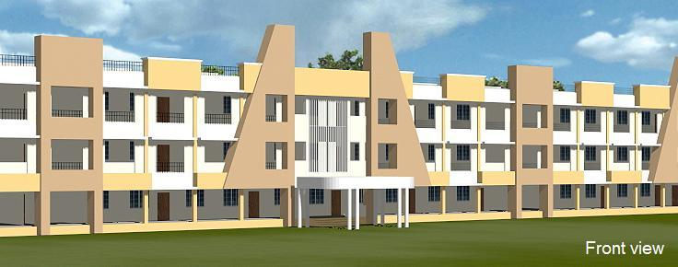

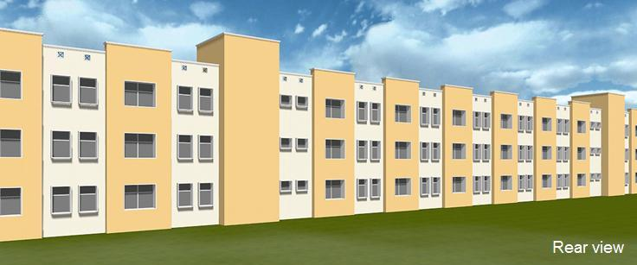

Budget
Income:
- Starting off with three divisions of 20 students each, we would gradually increase that to about 1200 in a span of seven years. The fees from the pupils constitute the major part of the income. The fee structure would be Rs. 9600 annually payable in four quarterly installments.
Initial income from fees : 60*9600= Rs 576000
Income from fees once the strength of 1200 is reached = Rs 11520000
- Donations from the pupils also add to the income of the school. A donation of Rs. 10,000 would be collected from each student.
- Initial income from donation = Rs. 600000
- Government fundings for library and computer labs also fall under the income.
Expenditure:
- staffing
- operational expenditure, ie rates, utilities etc
- resources
- SEN
- curriculum department spending
- standards fund expenditure
- premises/facilities (taken from the premises development plan)
- school future initiatives

